**Image Processing Project: Image manipulation program GUI**

To Instructor:

Dr. Mohamed Berbar

Submitted by:

1. Amira Sami Saad Omar – 1700067

**The main Interface**

1. When you run the project the following window will

appear to you.

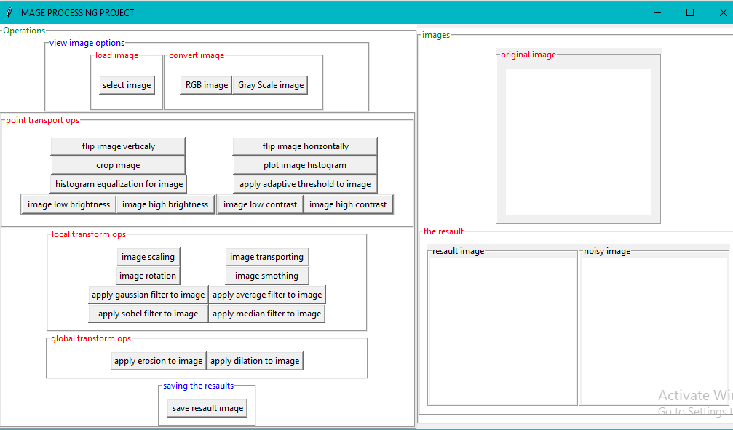

CLICK HERE TO BROWSE IMAGES

2. When you click select image button, the dialog box will appear. Then choose your photo and click open.

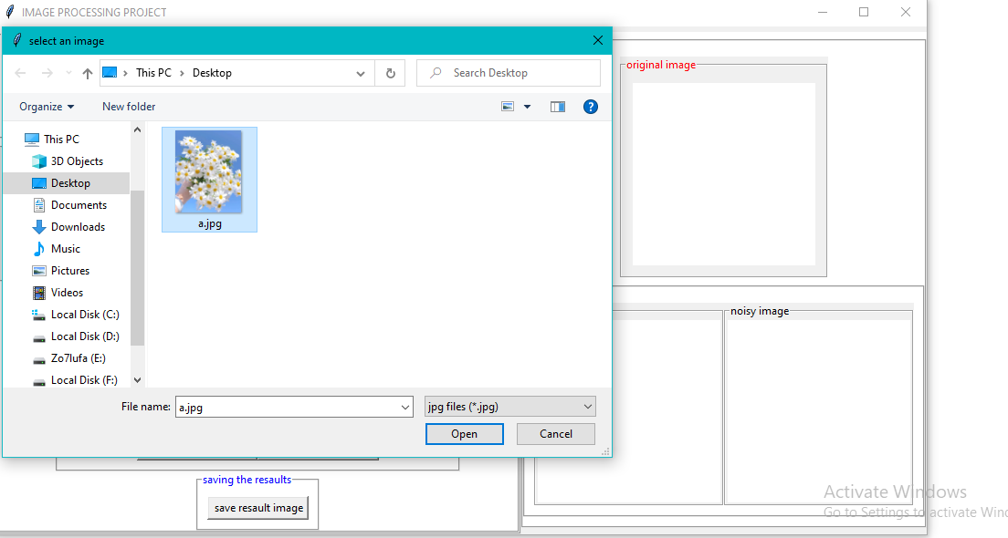

Click image to select it

Click open to load your image

3. -The image will display in RGB as a default color and you can convert it by click in Gray Scale image.

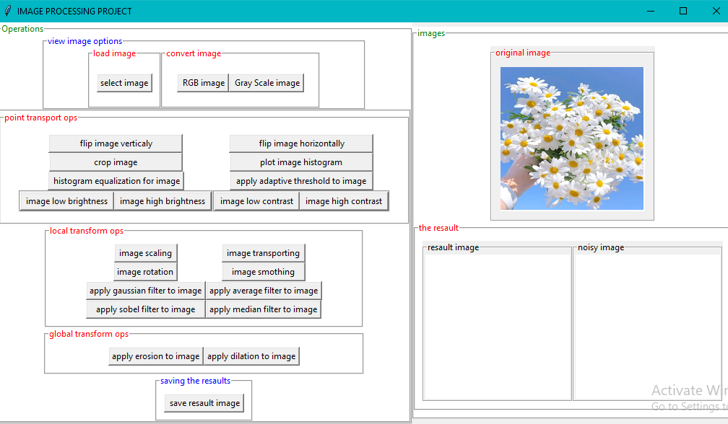

TO SHOW RGB IMAGE

TO SHOW GRAY SCALE IMAGE

4- YOU CAN VIEW THE IMAGE AFTER APPLING THE OPERATIONS IN THE RESAULT WINDOW

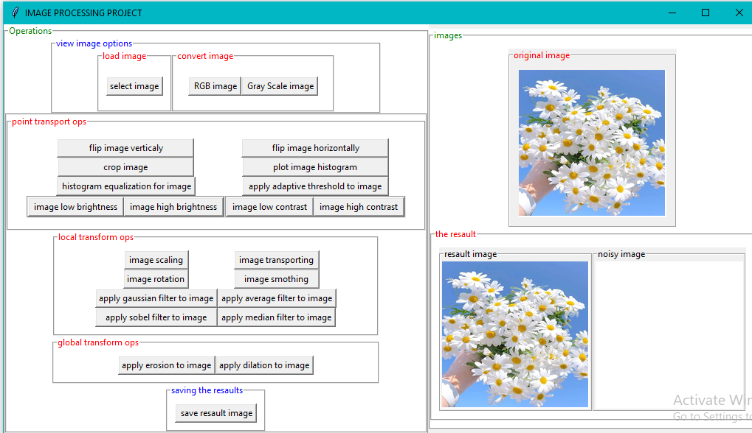

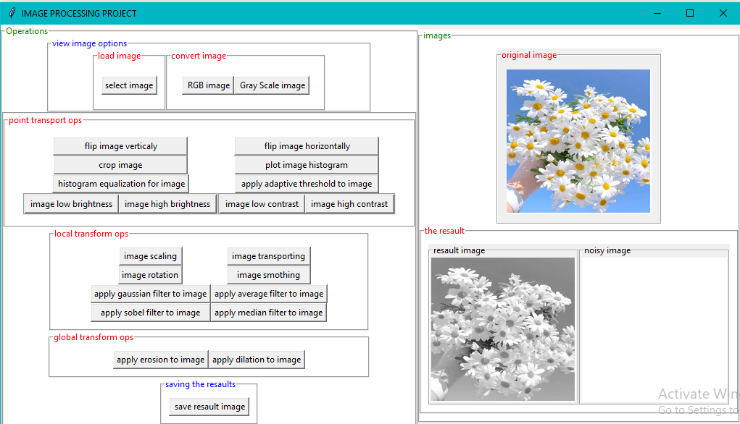

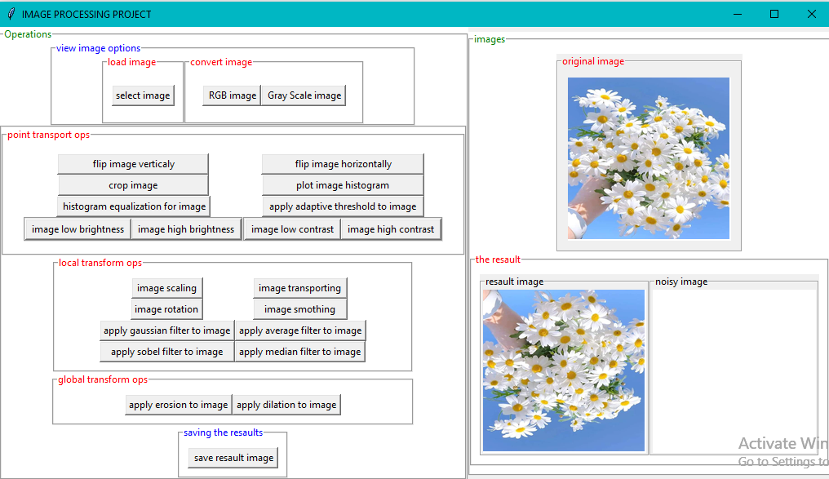FLIP IMAGE VERTICALY

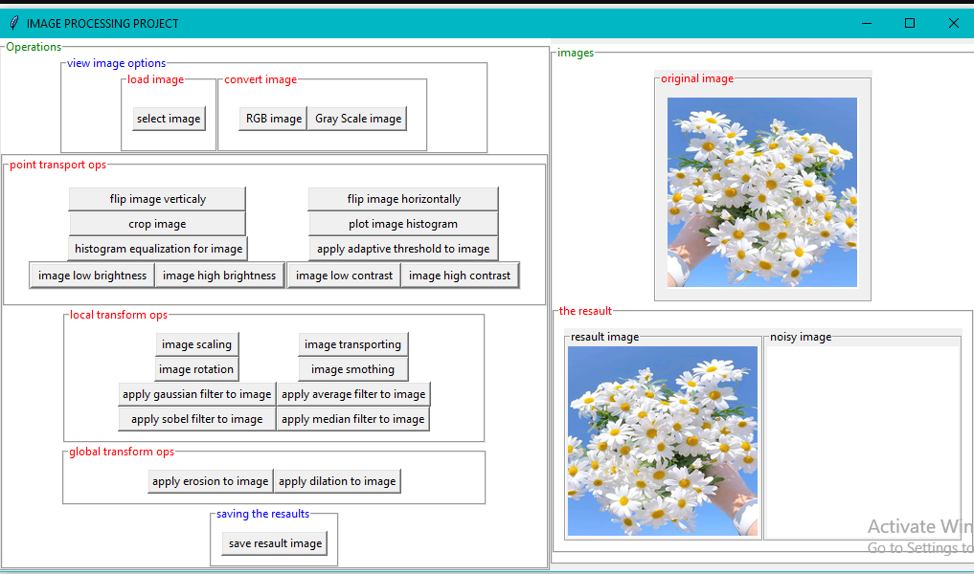

FLIP IMAGE HORIZONTALY

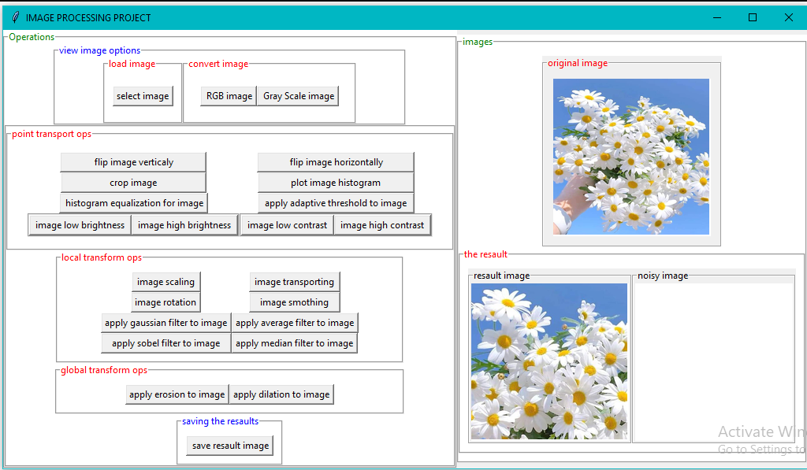

CLIP THE IMAGE

PLOT IMAGE HISTOGRAM

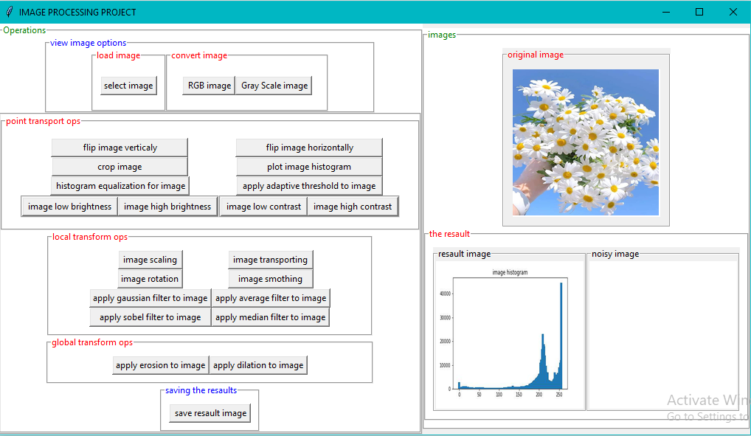

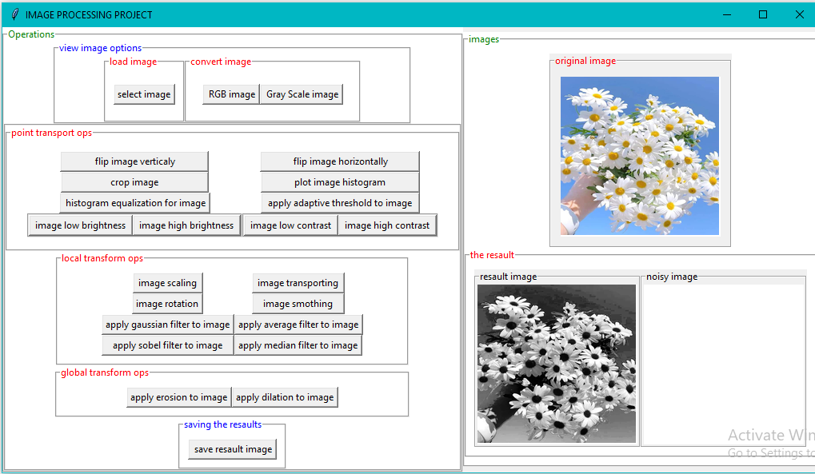

APPLY HISTOGRAM EQUALIZATION FOR THE IMAGE

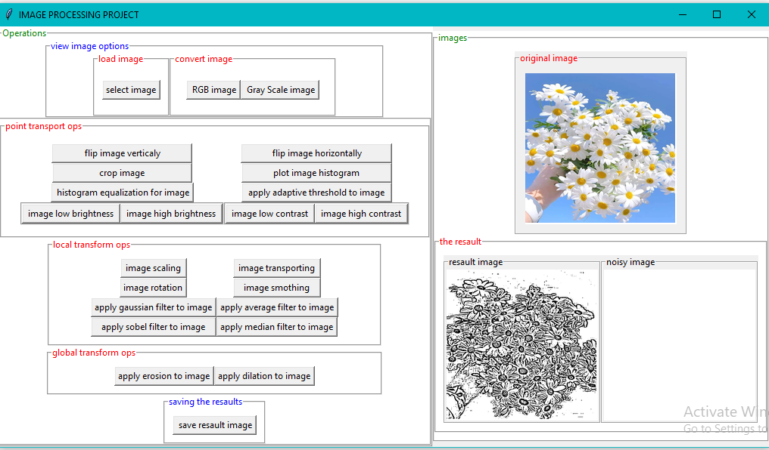APPLY ADAPTIVE THRESHOLD TO THE IMAGE

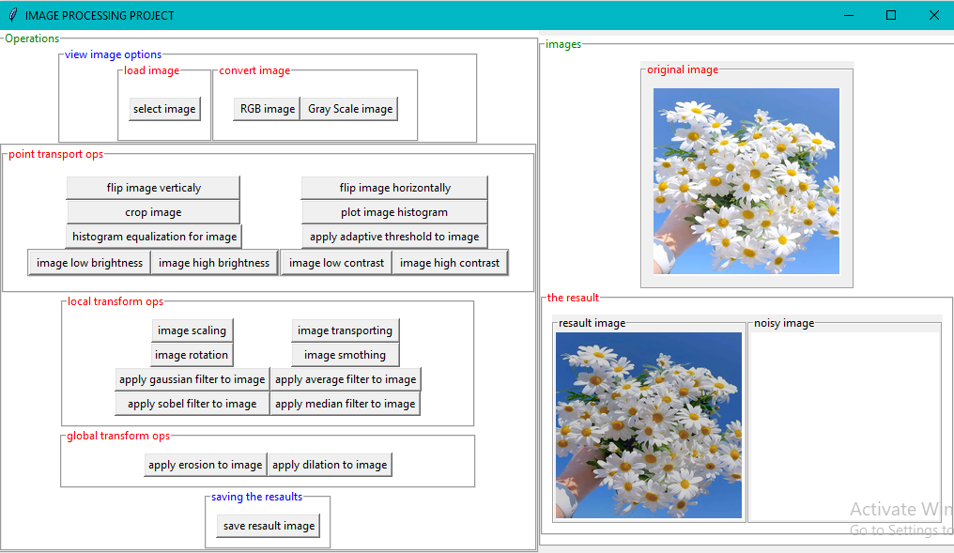

LOW BRIGHTNESS

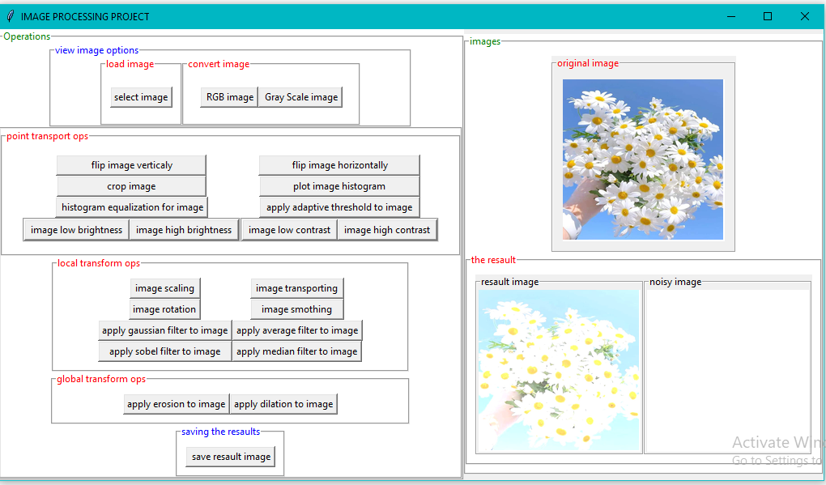

HIGH BRIGHTNESS

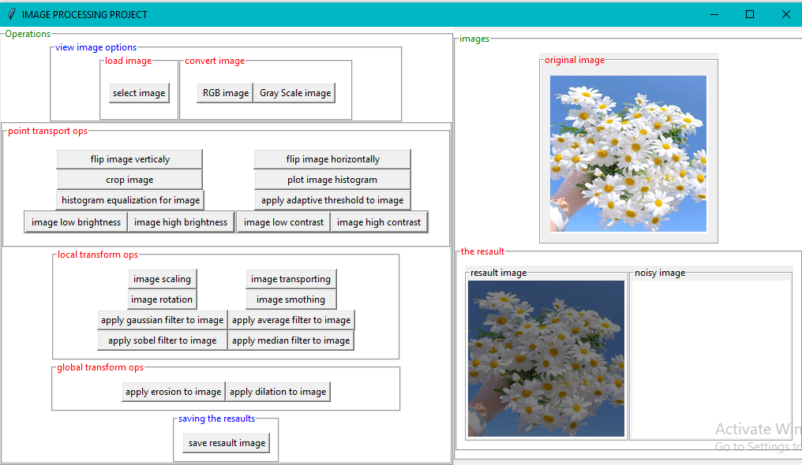

LOW CONTRAST

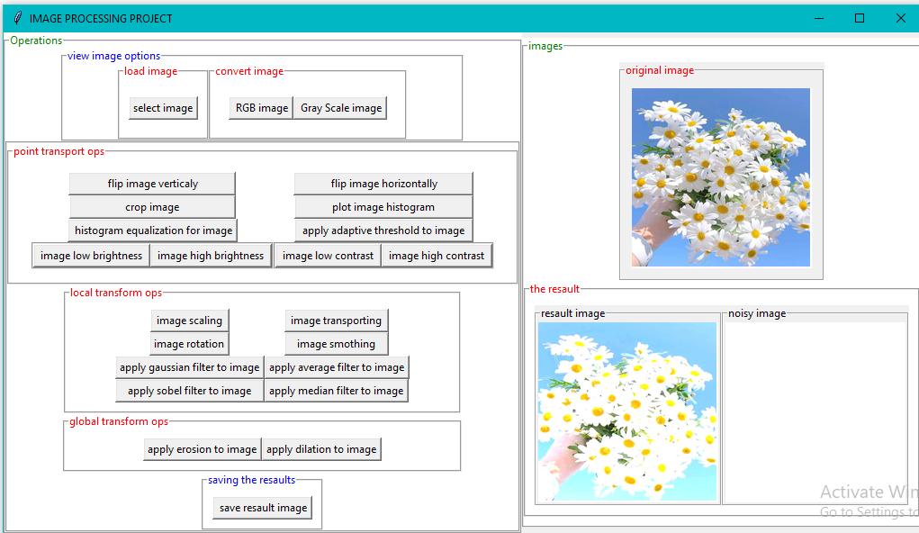HIGH CONTRAST

TRANSPORT THE IMAGE

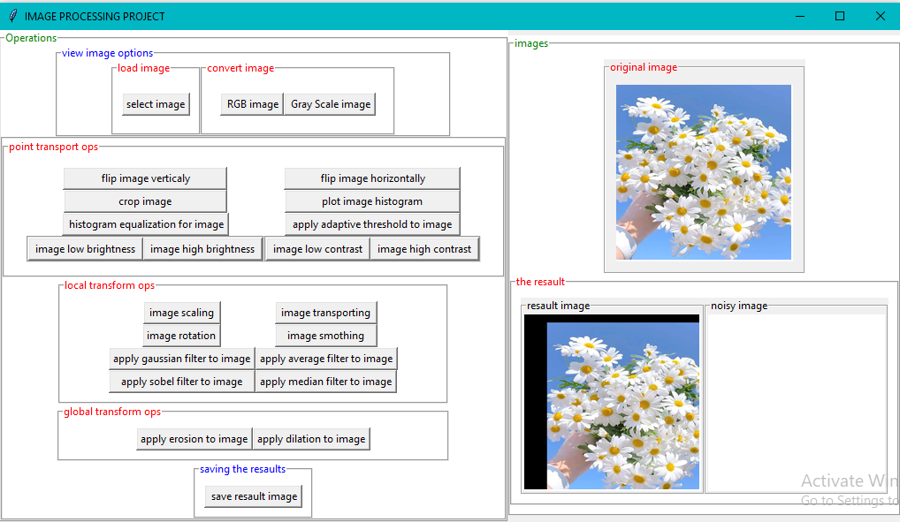

ROTATE THE IMAGE

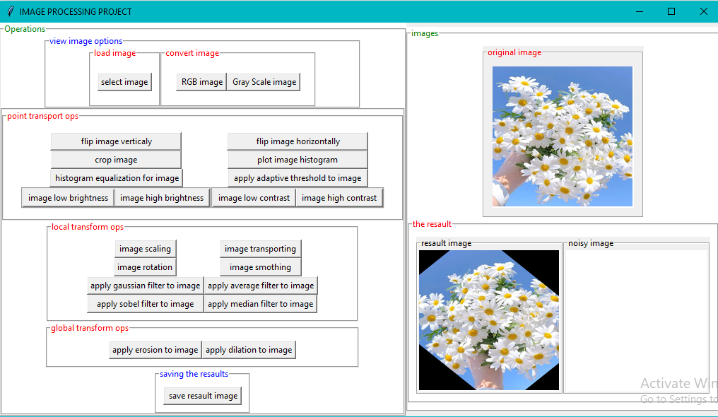

5- WHEN YOU USE FILTERS A GENERATED NOISE WILL BE APPLIED TO YOUR IMAGE BEFORE APPLING THE FILTER

APPLY LOW PASS FILTER TO IMAGE WITH SALT AND PEPER NOISE

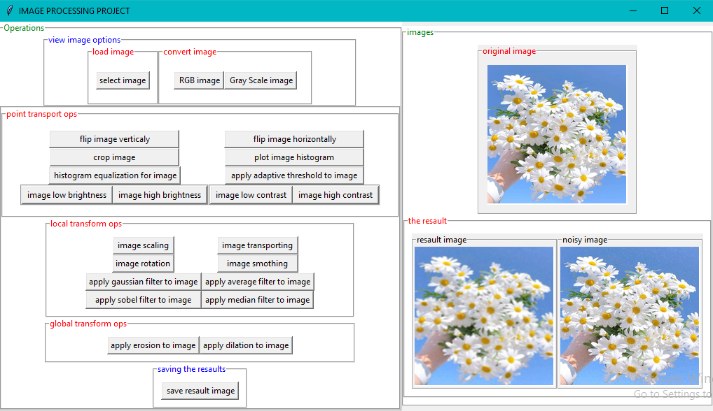

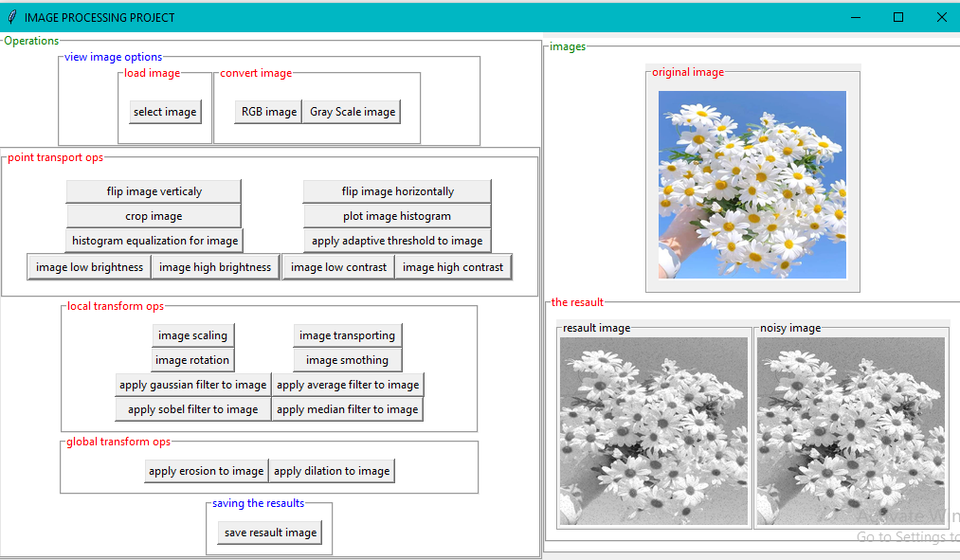

APPLY GAUSSION FILTER TO IMAGE WITH SALT AND PEPER NOISE

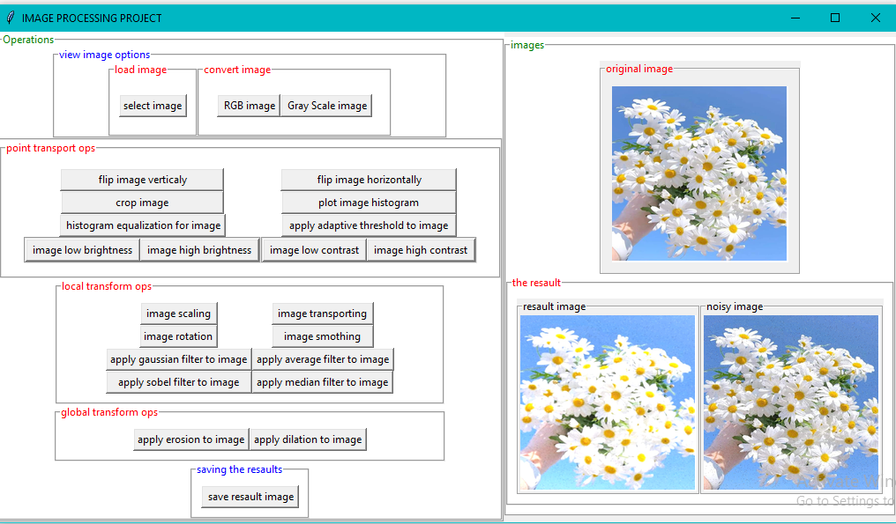

APPLY AVERAGE FILTER TO IMAGE WITH SALT AND PEPER NOISE

APPLY SOBEL FILTER TO IMAGE WITH SALT AND PEPER NOISE 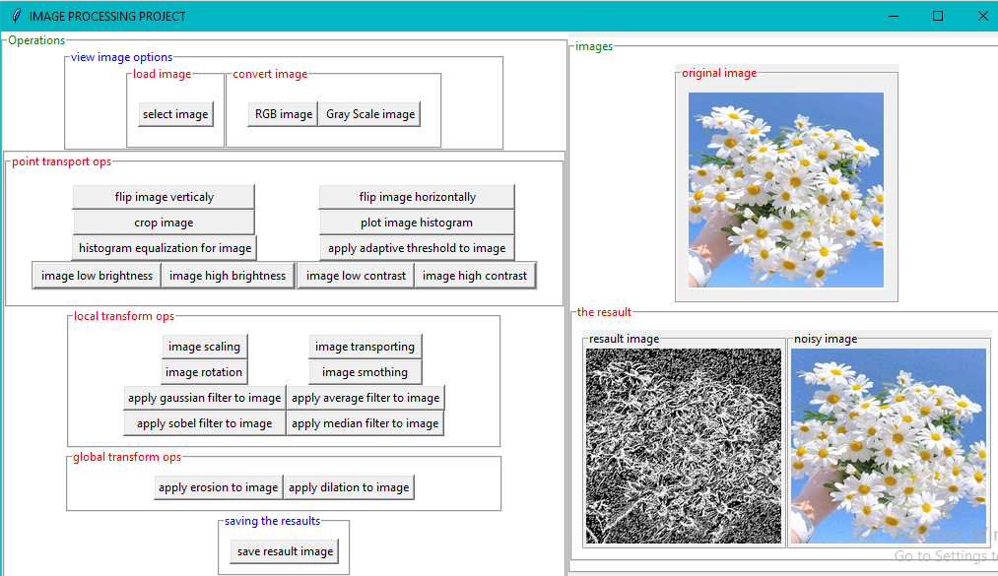

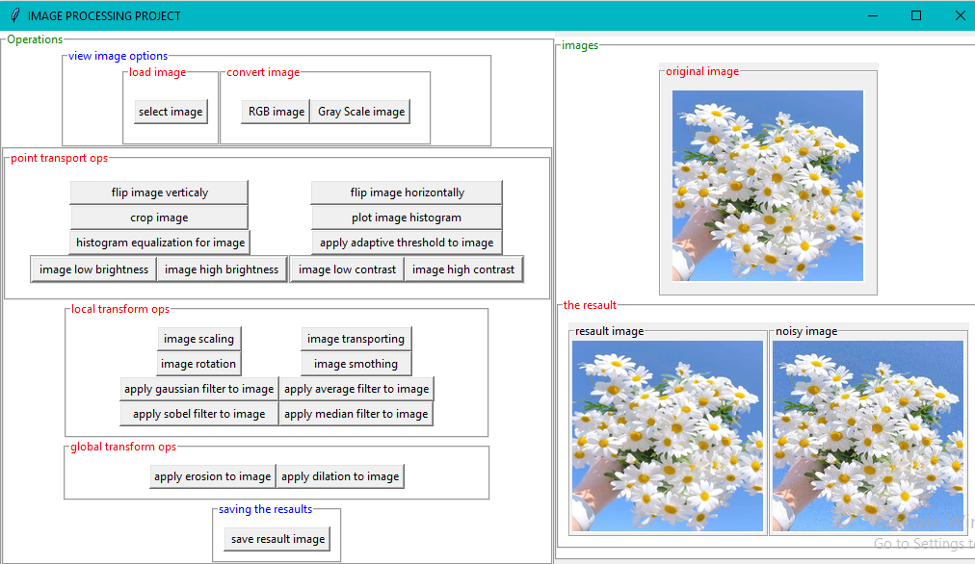

APPLY MEDIAN FILTER TO IMAGE WITH SALT AND PEPER NOISE

APPLY EROSION TO IMAGE

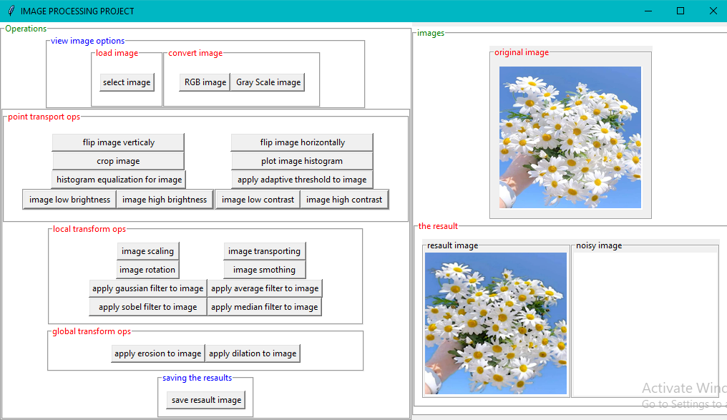



APPLY DILATION TO IMAGE

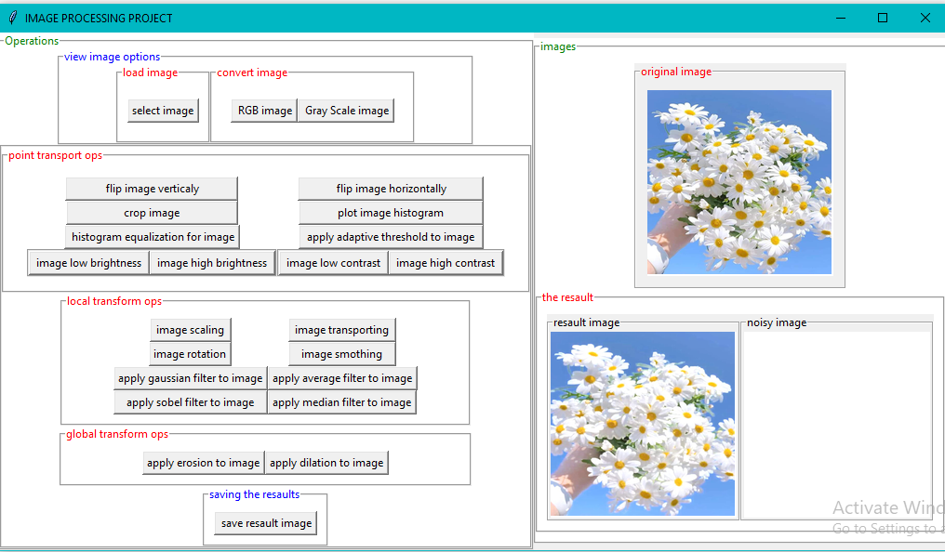

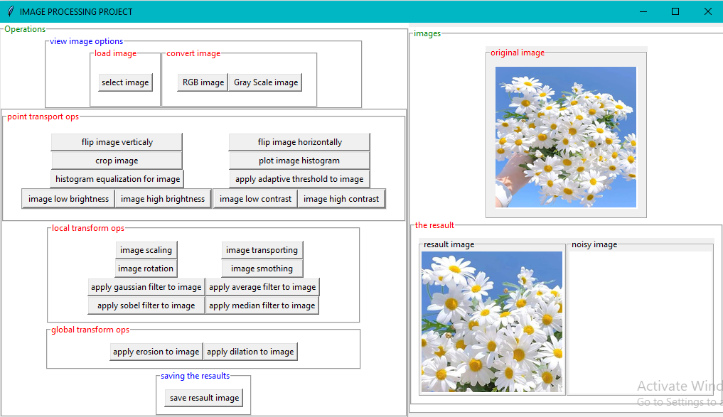

6-Also, you can save the image after apply operation to the image.

CLICK SAVE RESAULT IMAGE TO SAVE CURRENT RESAULT IMAGE

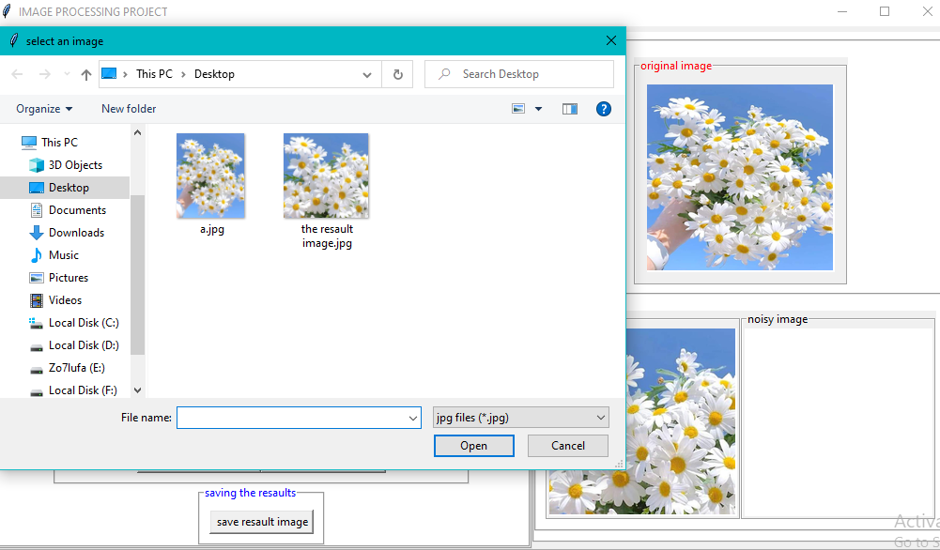

YOU CAN FIND THE SAFED IMAGE ON YOUR FILE

THANK YOU